**Weeek-1 (Assessment)**

**Step1:**

After installation of PowerBI to start with the project click on the **Blank Report**

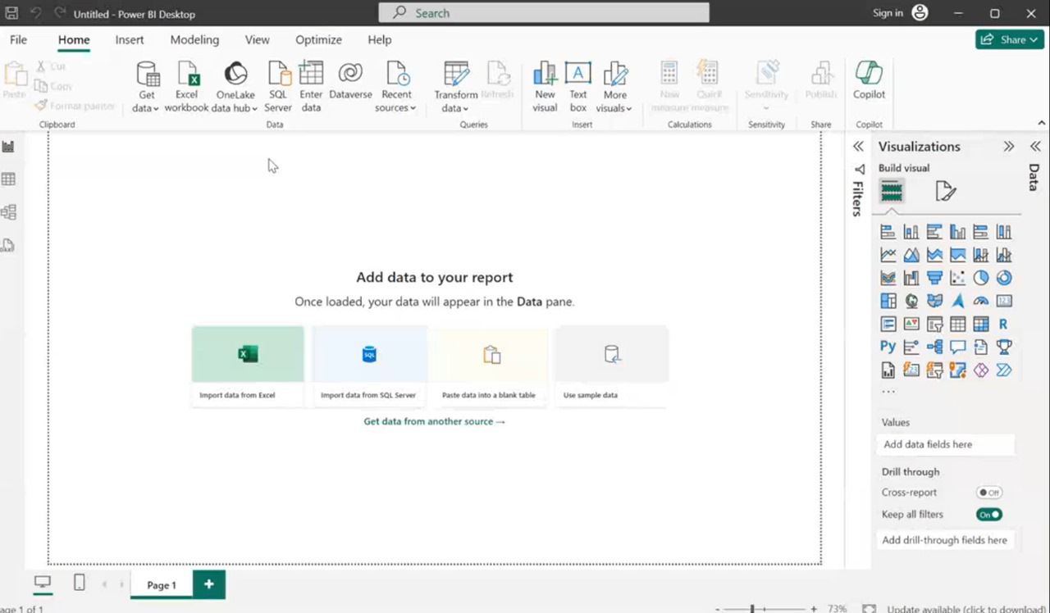

PowerBI Desktop

**Step2:**

Click on the get data and select the Text/CSV and **upload in the Sustainable Supply Chain Performance.csv file from our Device.**

Then one window will be open which gives overvewi of our data then click on the **Load** button

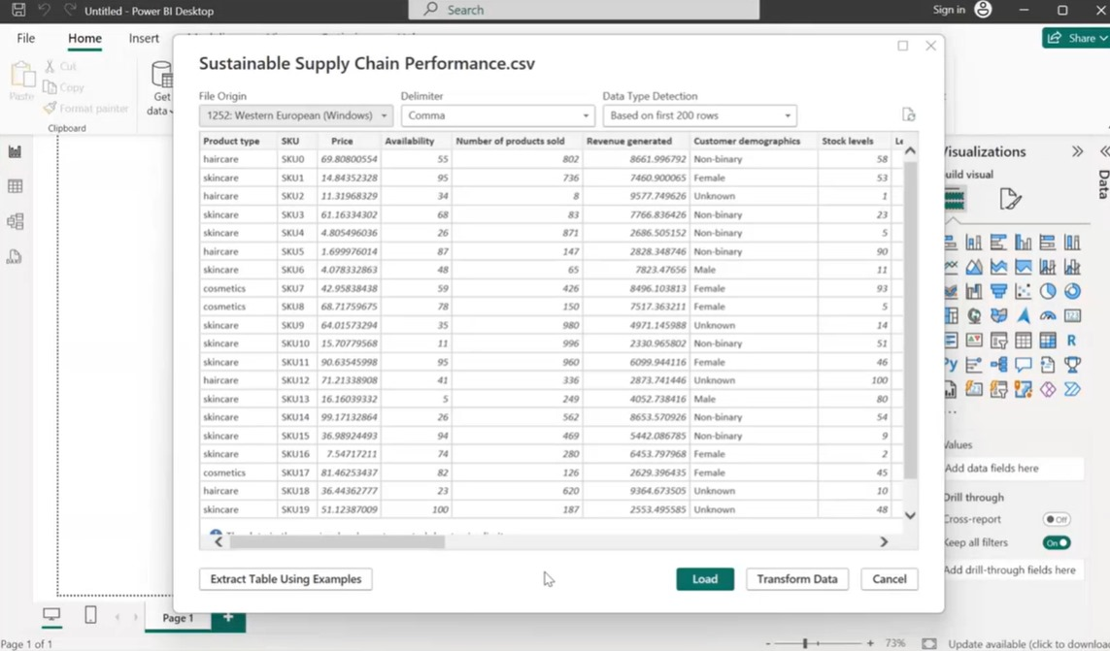

**Step3:**

To Transform the data click on **the Transform data** on the power BI destop which will be present on the top Then one new window 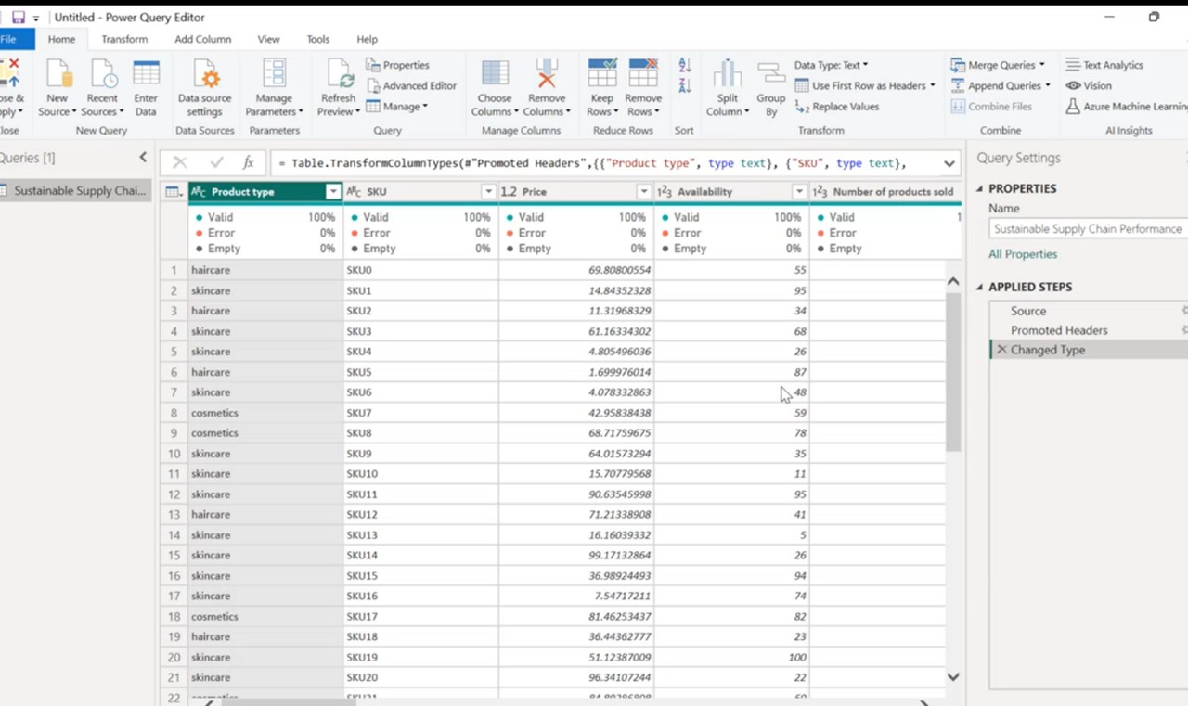will be open called **Power Query Editor**

**Step4:**

GO to the **veiw Tab** and click on the on the Column Quality which shows the quality of each column (Valid,Error,Empty).

**Step5:**

So Now we create new separate tables for the **Inventory table,Manufacturing Table,Supplier Table,Supply Chain Table** from our **Sustainable Supply Chain Performance table.**

To create new tables first you need to **Duplicate** of **Sustainable Supply Chain Performance table.** And rename them has the **Inventory table,Manufacturing Table,Supplier Table,Supply Chain Table.**

so in **Sustainable Supply Chain Performance table** we have 24 cloumns in it so we need to modify the tables as has according to our needs by removing unwanted columns.we remove columns by selecting them and click on delete button on keybord.

The Columns we require are for respective tables are:

**Inventory Table:**

1. Product type

2. SKU

3. Availability

4. Number of products sold

5. Customer demographics

6. Stock levels

7. Lead times

8. Order quantities

9. Lead time

10. Revenue generated

**Manufacturing table**

1. Product type

2. SKU

3. Production volumes

4. Manutacturing lead time

5. Manufacturing costs

6. Inspection results

7. defect rates

**Supplier Table**

1. Supplier name

2. Location

3. Lead time

4. transportation modes

5. Routes

**Supply chain table**

1. Product type

2. SKU

3. Price

4. Availability

5. Number of products sold

6. Revenue generated

7. Customer demographics

8. Stock levels

9. Lead times

10. Order quantities

11. Shipping times

12. Shipping Costs

13. Supplier name

14.Loctaion

15.Lead Time

16. Shipping carriers

17.Transportation moders

18.Routes

